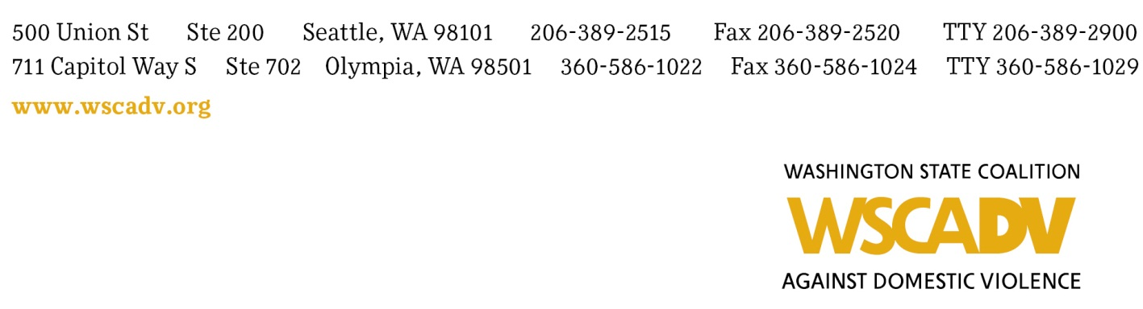

JOB POSTING
Applications Due by Friday, September 30, 5:00 pm

Position: ADMINISTRATIVE SPECIALIST, Domestic Violence Housing First - Seattle
Reports to: Housing Program Coordinator

Classification: Non-exempt
Compensation: $24.18 per hour, full-time (35-hour week), plus generous benefits (health, vacation, retirement contribution after one year, and more)

The mission of the Washington State Coalition Against Domestic Violence is to mobilize our member programs and allies to end domestic violence through advocacy and action for social change. We improve how communities respond to DV and create a social intolerance for abuse, support our member programs, and inform the public. We keep the experiences of survivors and their children at the center, especially those in communities of color and other historically marginalized communities. WSCADV’s team approach facilitates the sharing of power and responsibilities across positions and reflects the Coalition’s commitment to inclusion and leadership development.

The Administrative Specialist provides reliable, timely, and organized administrative and book-keeping support to the high-profile, fast-paced Domestic Violence Housing First (DVHF) demonstration and research project. DVHF strives to improve responses to domestic violence survivors and their children who face housing instability and homelessness. This position works closely with partners, consultants, major funders, and academic researchers located across the state and around the country. Because the project is rapidly developing, the job duties are subject to change over time. This is a grant-funded position with occasional overnight travel.

Responsibilities
- Provide primary administrative support to the DVHF project and its small team. Typical tasks include: tracking multiple deadlines and priorities, arranging travel, administrative and technical support for webinars, copy-editing and providing basic lay-out and design of PowerPoint slides and other materials, updating website content, maintaining email lists, designing and distributing emails, copying and making packets, and data entry.

- Provide executive assistance to the Housing Coordinator. In addition to the above, typical tasks include: planning meetings and trips, scheduling, making and answering phone calls, drafting emails, and coordinating with the researcher and consultants.

- Support the multi-year research project by coordinating logistics and administration with an out-of-state researcher and field teams in King County and Eastern Washington. This includes: preparing meeting agendas and summaries, including for a government panel; arranging travel and meetings; administrative support on hiring, payroll, and reimbursement documents for the field team; and administrative support for research briefings, reports, and dissemination.

- Provide bookkeeping and administrative support for invoicing, reimbursements, government grant reporting, project budgeting, and contracts management. Typical tasks include: drafting contracts and amendments, preparing invoices and gathering documentation, receiving and reviewing invoices, verifying contractors’ completion of deliverables and adherence to budget line items, preparing AR/AP items for the Accountant, and drafting budget reports.

- Organize and ensure smooth event production, including trainings, webinars, and meetings with researchers and major funders. Typical tasks include: planning; making arrangements for venues, catering, and travel; creating publicity, marketing, registration materials, and agendas; copying and making packets; taking notes; attending to onsite logistics; and post-event wrap-up.

- Support grant and contract reporting and communication, including: keeping track of reporting deadlines, drafting monthly reports and financials, scheduling reporting calls and meetings, and organizing records.

- Represent the project by clearly and tactfully communicating and supporting relationships with project partners, including WSCADV member programs, funders, and government agencies.

- Other duties as assigned.

- Perform all work in a culturally responsive manner consistent with WSCADV’s mission and Principles of Unity.

Required Qualifications
- Minimum 5 years’ experience in executive assistance, project management, administrative support, or program support or equivalent.
- Proficiency with Microsoft Office, especially Excel and PowerPoint. Proficiency or ability to quickly learn project management software, Constant Contact, and eTapestry. Comfortable with technology.
- Excellent project and event planning, time management, and written and oral communication skills. Detail-oriented, accurate, and organized. Quick learner.
- Ability to understand and interpret project budgets and make updates based on actuals.
- Excellent oral and written communication skills, including the ability to provide effective and tactful initial responses to stakeholder concerns.
- Commitment to maintaining a high degree of confidentiality and to effective representation of the project to the public.
- Proven ability to maintain calm, efficient, and good-humored approach to work while juggling multiple priorities in a highly productive work environment, and to work both independently and as a member of a team.
- Ability to think critically, carry out an assignment with limited direction, adapt to change, and be nimble and flexible.

Preferred Qualifications
- Proficiency with WordPress or HTML, and video conferencing software.
- Layout/design (especially for email communications and presentation slides) and copy-editing experience.
- Experience providing administrative support for academic research and grants/contracts administration.
- Familiarity with domestic violence and homelessness/housing issues.
- Spanish language oral and written proficiency is a plus.

To Apply
This position begins by mid-November 2016. To apply, please submit the following package:
- A cover letter summarizing your interest in and relevant experience for this position;
- Your resume;
- 3 references (2 of which must be professional)

Email to: ben@wscadv.org (subject line: Administrative Specialist Hiring – [your last name]) Applications must be received by 5:00 p.m. on September 30. No calls, please.

People of color, Native people, people with personal experience with housing instability or homelessness, and survivors of domestic violence are especially encouraged to apply.

