- 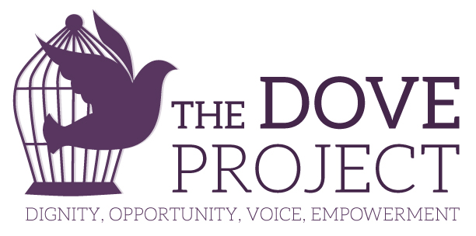
- Job Announcement

September 2016

- Legal Advocate
Job Title | Legal Advocate
Reports to | Executive Director
Location | Vashon, WA
Exempt or Non-Exempt | Non-Exempt
Posting Date | 9/21/2016
Closing Date | 10/05/2016
Compensation | $15.00/hour
Hours | 25 Hours per week  Starting January 1, 2017 or sooner depending on training
The DoVE Project is a comprehensive provider of domestic violence services, including an Advocacy & Crisis Line, survivor support groups for women and for men, immigration and legal support, and teen prevention work. The DoVE Project’s mission is to provide compassionate advocacy to survivors of domestic violence living on Vashon Island through support and direct services. Our goal is to build a community in which abuse is eliminated and personal empowerment is promoted through prevention, education, and training.

Overview of Position
The Legal Advocate provides direct services to victims of domestic violence on Vashon Island. The Legal Advocate’s direct service responsibilities include providing support, information, and advocacy to victims of domestic violence including assistance with restraining orders, civil, criminal, and other court matters, and legal referrals. The Legal Advocate is not a lawyer and does not give legal advice.

Duties and Responsibilities Direct Service:
- Work with clients by phone, email, in face-to-face meetings, and in court.
- Provide information about restraining orders, family court, criminal court, immigration laws, and other legal procedures.
- Provide information and referrals about legal and other community resources.
- Assist clients in safety planning, identifying options, and problem-solving.
- Provide client-specific advocacy to meet identified client needs, such as contact with other service providers, law enforcement, and others.
- Assist clients in filling out and filing restraining order paperwork and attending injunction hearings.
- Assist clients in filling out and filing family court paperwork and attending hearings.
- Accompany clients to other hearings as required.
- Keep supervisor informed of high-risk situations in work with clients.
- Adhere to organization policies and work rules, including confidentiality and code of ethics. Maintain professional boundaries with organization clients.
- Staff the DOVE Help Line.
- Other duties as assigned.

Advocacy, Outreach, and Organization Representation:
- Provide community education as assigned.
- Provide professional training to groups such as law enforcement and other partner agencies as assigned.
- Active participation at community meetings related to improving the community’s response to domestic violence.
- Establish and maintain collaborative relationships with community partners.
- Identify, track, and address legal systems issues in community meetings and special projects.
- Other duties as assigned.

Record-Keeping and Other Responsibilities:
- Complete all required service documentation in a thorough and timely manner.
- Participate in organization grant and contract reporting as directed by supervisor.
- Adhere to organization policies and work rules.
- Consult with supervisor in weekly meetings about client concerns, workload management, professional development, and other areas.
- Attend trainings and continuing education activities as assigned.
- Active participation in Legal Advocacy Program meetings about client needs, scheduling, and other team issues.
- Attend organization staff meetings as required.
- Other duties as assigned.

Qualifications
- Four-year college or university degree. Relevant experience can be substituted for a degree.
- Knowledge of issues that affect victims of domestic violence and their children.
- Knowledge of the legal rights of victims and the civil and criminal legal systems preferred.
- Ability to work sensitively with traumatized populations and to handle crisis effectively.
- Demonstrated ability to work with diverse populations.
- Ability to work independently and as a member of a team.
- Effective oral and written communication skills with clients, co-workers, and community partners.
- Excellent organizational skills.
- Leadership and positive representation of the organization in the community.

This position is required to:
- Complete WSCADV New Advocate training program.
- Consent to a Criminal Background Check

To apply:
Send resume and cover letter to Betsey Archambault Betsey@vashondoveproject.org, detailing your unique interest and qualifications for this position.

The DoVE Project is an equal opportunity employer. We do not discriminate in hiring or employment on the basis of race, color, religion, sex, national origin, ancestry, age, marital or veteran status, disability, gender identity, sexual orientation, gender expression, gender identity or any protected status.

Disclaimer
Employment is contingent upon successful completion of a Washington State Patrol background check.

The above statements are intended to describe the general nature and level of work being performed by people assigned to this classification. They are not to be construed as an exhaustive list of all responsibilities, duties, and skills required of personnel so classified. All personnel may be required to perform duties outside of their normal responsibilities from time to time, as needed.

